Funded by Ontario Trillium Foundation (OTF) – Resilient Communities Fund

April 2026
Prepared by the Peel Institute of Research and Training, Family Services of Peel
Resilient Communities Project
Final Report
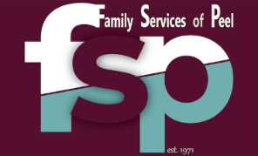
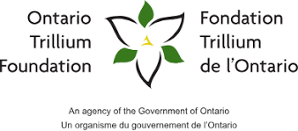
Table of Contents
Introduction 1
Project Components and Key Findings 1
Retrospective Study and Internal Data Review 1
Job Shadowing 3
Focus Groups and Interviews 3
Scoping Review #1: Models and Frameworks for Mental Health Counselling in Non-Profit Agencies 3
Scoping Review #2: Understanding The Key Elements and Outcomes of WIC Programs 5
Internal Counselling Program Meeting 5
External Partner Meeting: Building Best Practices for Counselling Services in the Region of Peel 6
Recommendations 6
Recommendations for Data Integrity: Improving Ongoing Data Collection and Analysis 6
Recommendations for Partnership Building and Community Connections 6
Recommendations for Models, Frameworks, and Modalities 7
Recommendations for Policies and Procedures 7
Recommendations for Administration, Efficiency and Efficacy, and Client Flow 7
Recommendations for Service Demand Generation 8
Recommendations for Future Research to Identify Best/Promising Practices for Counselling Programs 8
Recommendations for future OTF projects 9
Appendices 10
Appendix A: Proposed Counselling Program Workflow 10
Appendix B: Scoping Review #1 Data Screening Flow Diagram 11
Appendix C: Scoping Review #2 Data Screening Flow Diagram 12

Introduction
In 2024, Family Services of Peel (FSP) and the Peel Institute of Research and Training (PIRT) began a two-year Ontario Trillium Foundation (OTF)-funded project—the Resilient Communities Project—seeking to enhance FSP’s Counselling Program in the post-pandemic environment. The COVID-19 pandemic caused major disruptions in multiple areas of life, including a profound impact on mental health and an increased demand for psychological support. In turn, agencies offering mental health counselling had to find creative and alternative ways to respond to the greater demand. FSP shifted to virtual services, and later, pivoted to a hybrid approach, while continuing to navigate the increasingly complex and multi-layered nature of client needs. The changing counselling landscape and intensification of client needs required FSP to devise new solutions to ensure ongoing responsiveness. Given this context, we proposed the Resilience Project to determine how FSP may best serve clients’ emerging needs and how to adapt the existing walk-in counselling (WIC) and ongoing counselling programs accordingly. The project objectives included:
- Collect and analyze internal data to understand (a) recent client demographics, (b) emerging client needs, (c) services provided, and (d) current program gaps and areas for improvement.
- Conduct literature review(s) to identify potential best or promising practices for counselling services in non-profit settings.
- Examine and implement new technologies that can support service efficiency and effectiveness.
- Develop and pilot a new treatment model to address emerging client needs.
  - Unfortunately, due to various project delays and changing needs over time, a model was not developed for piloting. Rather, we established a set of recommendations that can support FSP and counselling staff to develop an operating model to address emerging client needs in the next three years.

Project Components and Key Findings
The Resilient Communities Project involved a concurrent, multi-methods project design, including (1) a retrospective study and internal data review, (2) job shadowing, (3) internal focus groups and interviews, and (4) two scoping reviews. We briefly outline each project component in this report, with links to complete reports provided.

Retrospective Study and Internal Data Review
Retrospective Study
To generate a baseline understanding of the clientele using FSP’s Counselling Services, PIRT conducted a retrospective study for the period of January 1, 2021 to August 31, 2023. The objectives of the retrospective study were to (1) describe the demographic characteristics, life events, and the reasons clients contacted counselling services; (2) describe the enrollments of the main types of services and referrals provided by FSP Counselling Services; and (3) determine the integrity of the data retrieved from the existing database system (CaseWorks). A random sample of 320 enrollments was extracted from CaseWorks—representing 10% of total (N=3,164; n[WIC] = 2,463; n[ongoing] = 701) enrollments—for data analysis. Table 1 outlines the primary findings from the retrospective study.
Table 1
Retrospective Study Findings
Client Demographics | Gender | Women: 65% |  | Men: 45%
Client Demographics | Age | Under 18: 2.5%  18 to 24: 9.1%  25 to 34: 24% | 35 to 44: 19.1%  45 to 54: 16.9%  55 to 64: 13.1% |  | 65 to 74: 4.7%  75+: 2.8%  No response: 7.5%
Client Demographics | City of residence | Mississauga: 39.1% | Brampton: 23.1% |  | Other: 4.4%  No response: 33.4%
Reasons for seeking counselling | - Stress/anxiety: 50.1%  - Depression: 17%  - Mental illness: 7.3%  - Trauma/PTSD: 7.1%  - Abuse/violence: 6.5%  - Other (i.e., Anger, Grief, Addiction): 12%
Referrals | Nearly 43% of the enrollments had internal referrals; the majority of them (25%) were outgoing internal referrals from walk-in counselling.
Data Integrity | - Demographic Data: Except for age, gender and place of residence, there is no other demographic data stored in CaseWorks.  - Different data were entered in CaseWorks between walk-in and ongoing counselling.  - More than half of the enrollments have not been identified as to whether a referral was made or whether it was a self-referral.  - One percent of the enrollments have been identified as self-referrals.
Internal Data Review
In early 2026, PIRT conducted an updated internal data review of the Counselling Program for the period of January 1, 2024 to December 31, 2025—the period covered by the Resilient Communities Project and covering the implementation of EMHware—to (1) determine how many new (distinct) clients had been served; (2) determine how many clients had been served (including new and repeat clients); (3) understand the updated demographic profile of clients; and (4) ) determine the integrity of the data retrieved from the new database system (EMHware). PIRT also analyzed data from a sample of 207 pre-and post-surveys completed by clients who used WIC between 2024 to 2025. Table 2 provides a brief summary of the internal data review and WIC survey analyses.
Table 2
Summary of internal data review findings
New clients (2024-2025) | Total (2024-2025): 862  2020: 455 2024: 529 2025: 475
Number of counselling sessions | - Total: 4,539 sessions (84% ongoing; 16% walk-in)  - Walk-in: The vast majority (92%) attended only one or two sessions, a few clients (7%) attended 3 sessions, and a minority (2%) had 4 or 5 sessions, but not more than 5.  - From ongoing: About one-third of the clients (34%) had 1 or 2 sessions, 22% of clients attended between 3 and 5 sessions, and 44% had more than 5 sessions.
Demographic data collection integrity | - Data has been collected consistently for the client’s age, city of residence, address, and phone number, which are needed to contact the client and achieve the basic functionality of the database system.  - No data has been collected in relation to Immigration Status, Marital Status, Ethnicity, Country of Birth, Level of Education, Employment Status, Income, Housing, or Family Composition.  - There were inconsistencies in collecting gender information, due to variation in client contact methods (in-person vs over the phone) and the preference of clients to disclose gender information.
Pre- and Post-Surveys | - The high rate (more than 80%) of no responses to the post-survey prevents valid comparisons and precludes strong conclusions on the efficacy and client satisfaction of WIC.  - Surveys conducted in paper format require time to convert to electronic format for data analysis.  - There were no timely data analyses of the WIC survey; thus, the results have not been used to improve the services.

Job Shadowing
A critical component of our exploration involved job shadowing administrative staff at the Counselling Program to understand their day-to-day responsibilities. This exercise revealed several inefficient and redundant processes that hindered the smooth functioning of the program. The current processes involved an overlap in responsibilities between staff members, creating duplication and inefficiency. Based on the identified inefficiencies, PIRT suggested (1) restructuring staff roles and responsibilities to delineate roles, to ensure that each staff member works within their area of expertise, and (2) a proposed client flow through the program (Appendix A).

Focus Groups and Interviews
PIRT conducted two focus groups and two semi-structured interviews with FSP counselling staff. During the focus groups and interviews, we asked counselling staff a series of questions about their experience working in the walk-in and ongoing counselling programs, program successes and challenges, differences between the program streams, changes in client needs and demand since the onset of the COVID-19 pandemic, referral processes, ways to ensure adequate service delivery and support for clients moving forward, and professional development. Figure 1 provides an overview of the themes and subthemes generated from the focus group data.
For the full focus group report, please visit: https://pirt.fspeel.org/wp-content/uploads/2026/04/Qualitative-Data-Analysis-Report.pdf

Scoping Review #1: Models and Frameworks for Mental Health Counselling in Non-Profit Agencies
To enhance the counselling program at FSP, we conducted a scoping review of existing academic and grey literature on overarching models and frameworks used in non-profit organizations to implement, deliver, and/or evaluate mental health programs. The objectives were to (1) Identify existing evidence on overarching models and frameworks used in non-profit organizations to implement, deliver, and/or evaluate mental health programs; (2) Characterize the identified counselling models and frameworks in terms of key elements, components, and other characteristics; and (3) Provide recommendations for mental health counselling within FSP, based on the findings from Objectives 1 and 2.
Based on our synthesis and analysis of 14 included articles, we found that the models and/or frameworks used in mental health counselling programs offered by non-profit organizations varied greatly. Within the included studies, minimal overlap in the models described and/or assessed could be identified, preventing us from drawing broad conclusions regarding key model elements, types, characteristics, and outcomes. Our analysis showed that we may conceptualize models/frameworks used by non-profit organizations for mental health programs within an overarching conceptual integrated systems framework that comprises four nested frameworks (Figure 2): (1) evaluation framework(s); (2) macro-level framework(s); (3) implementation framework(s); and (4) service delivery framework(s). Appendix B contains the Data Screening Flow Diagram.
Figure 1
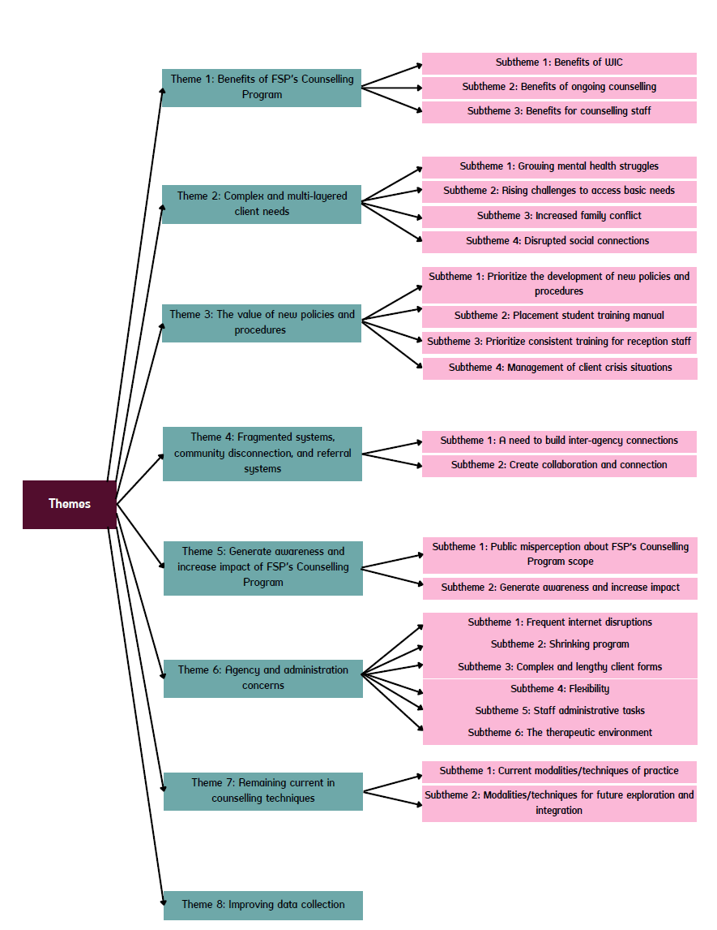
Summary of focus group and interview themes and subthemes

Figure 2
Conceptual Integrated Model for Counselling Programs in Non-Profit Agencies
Evaluation Framework

Macro-Level Framework

Implementation Framework
Service Delivery Framework

For the full scoping review report, please see: https://pirt.fspeel.org/wp-content/uploads/2026/04/Models-and-Frameworks-for-Mental-Health-Counselling-in-Non-Profits.pdf

Scoping Review #2: Understanding The Key Elements and Outcomes of WIC Programs
To strengthen FSP’s WIC program and meet the emerging needs of clients, we identified a need to better understand the approaches taken to WIC in non-profit-based mental health and family counselling agencies. To achieve these aims, we conducted a rapid scoping review of academic and grey literature on existing WIC models, frameworks, and approaches implemented in non-profit mental health and family counselling organizations. The objectives were to (1) Identify and understand existing evidence on models, frameworks, and approaches used for WIC programs in non-profit mental health and family counselling organizations; (2) Characterize these WIC models, frameworks, and approaches according to the populations served, types of providers involved, therapy modalities adopted, delivery models used, and program impacts; and (3) Identify and characterize best practices for WIC programs in community mental health and family counselling organizations.
Based on our synthesis and analysis of 48 included articles, encompassing 36 distinct WIC programs and/or approaches from Canada, the United States, Australia, Germany, and Mexico, we presented key findings related to (a) characteristics of WIC models, (b) elements of successful WIC programs, (c) client outcomes, and (d) benefits of WIC programs. Appendix C contains the Data Screening Flow Diagram.
For the full scoping review report, please see: https://pirt.fspeel.org/wp-content/uploads/2026/04/Walk-in-Counselling-Scoping-Review.pdf

Internal Counselling Program Meeting
In late February 2026, FSP-PIRT hosted an internal meeting with the FSP Counselling Program team to share key findings from the 2024-2026 Resilience Project. The Manager of Counselling Services, six counsellors, and two counselling social work placement students attended this event. During this meeting, the PIRT team presented the findings from two key project components: (1) internal counselling program data review, and (2) the WIC scoping review. These presentations were followed by a facilitated discussion on how specific findings and recommendations may be implemented in practice.
For a full overview of the outcomes and findings of this event, please see: https://pirt.fspeel.org/wp-content/uploads/2026/04/Resilience-Project-Internal-Event_REPORT.pdf

External Partner Meeting: Building Best Practices for Counselling Services in the Region of Peel
In late March 2026, FSP-PIRT hosted a final project meeting with a select group of leaders from non-profit agencies in Peel who provide counselling services. The objectives of the event were to (1) Bring together a group of senior leaders from across the Region of Peel to discuss the findings from our project, (2) Identify how our project findings can support the current work of non-profit agencies in the Region of Peel, and (3) Identify pathways to collectively enhance evidence-informed walk-in and ongoing counselling programs and strengthen data sharing to best serve our Peel-based clients.
For a full overview of the outcomes and findings of this event, please see: https://pirt.fspeel.org/wp-content/uploads/2026/04/Building-Best-Practices-for-Counselling-Services-in-Region-of-Peel.pdf

Recommendations
From each project component, we developed recommendations for FSP’s counselling services. These recommendations have been synthesized across core areas for ongoing improvement.

Recommendations for Data Integrity: Improving Ongoing Data Collection and Analysis
The retrospective study, internal data review, and focus groups and interviews highlighted that FSP’s data collection and analysis systems require substantial improvement to ensure robust ongoing program monitoring and evaluation. Based on our findings, we offer the following recommendations for improved data collection and analysis in FSP’s Counselling Program:
- Review and update FSP Counselling Program policies and procedures related to data integrity, data flow, and documentation quality for counselling services.
- Utilize the PIRT research team to support with robust data collection and analysis of FSP’s counselling program, and ensure results are communicated and shared with counselling staff
- Establish a continuous data quality improvement process for FSP’s Counselling Program, aligned with service delivery procedures. This framework will progressively resolve critical errors and data gaps to meet specific quality targets.
- In collaboration with PIRT Implement robust methods of evaluation for both WIC and ongoing counselling programs. It is highly recommended, based on the reviewed programs, that FSP consider the implementation of the Partners for Change Outcome Management System (PCOMS).

Recommendations for Partnership Building and Community Connections
During the focus groups and interviews, the counselling staff highlighted that community connections and partnerships need to be strengthened to aid information sharing, counsellor knowledge of community services, client referrals, and demand generation. The WIC scoping review provided further support for the importance of partnership building across agencies. Based on our findings, we recommend the following:
- Prioritize community partnership building for information sharing, client referrals, and counsellor knowledge of community services.
- Develop and implement a strengthened internal and external referral and contra-referral system in the counselling program.
- Develop a shared resource hub in which counsellors can access a breadth of resources.
- Increase community connections and partnerships to generate demand for the WIC program. Explore non-traditional partnerships opportunities with for-profit companies, libraries, recreation centres, and other entities to expand reach and accessibility of WIC programs.

Recommendations for Models, Frameworks, and Modalities
To strengthen the use and integration of models, frameworks, and modalities, we recommend the following:
- To strengthen services for families, provide and/or recommend training sessions for counsellors in family-specific modalities, to enhance skills and capacity to work with family units.
- To build counsellors’ capacity to meet clients’ evolving and complex needs, utilize appropriate training programs and professional development courses in which staff can partake, and/or make use of Peer-to-Peer meetings as an informal training space.
- It is important that clinicians be trained in systemic and brief therapies that emphasize client strengths and resources. Clinicians must be pragmatic and aim to provide a clear outcome for clients within a single session to ensure robust WIC services.
- Consider the conceptual integrated systems model to guide future adaptations to FSP’s Counselling Program including Disability Services and Employment Services.
- Utilize evidence-based implementation frameworks and strategies when making any future changes to provide strong guidance, measurable constructs, and increase staff trust and motivation.

Recommendations for Policies and Procedures
During the focus groups and interviews, the lack of updated policies and procedures arose as a critical gap. Developing and implementing new policies and procedures for the Counselling Program will be crucial for FSP.
- The counselling program requires the introduction of new policies and procedures to inform both counselling and reception staff on the current state of the WIC and ongoing programs, to provide protocols on handling specific situations, and to inform training for new staff.
  - A specified review period for updates must also be implemented.
  - Protocols for managing client crises must be developed and implemented, and training must be provided. Reception staff do not have the clinical background or training to manage crisis situations. As such, a review is needed on how many counsellors are always present at FSP.
  - Develop internal policies and procedures for placement student training and supervision.
- All reception staff at FSP must be consistently and comprehensively trained in the new counselling program policies and procedures, triaging client calls, handling confidential information, and other relevant skills. As well, they must receive training in trauma-informed, culturally sensitive, and anti-oppression and anti-racism care.

Recommendations for Administration, Efficiency and Efficacy, and Client Flow
We identified several administrative gaps and barriers that require actions to improve the operations of FSP’s Counselling Program.
- Restructure staff roles and responsibilities to ensure clear delineation of roles to ensure that each staff member works within their area of expertise. This will improve service delivery, reduce duplication, and increase program efficiency.
- Hire a Counselling Program Intake Worker who is a qualified counsellor with specialized training, to ensure appropriate preliminary assessment and triaging of clients.
- Implement the proposed client flow through the program (Appendix A), or an adapted version.
- Streamline administrative tasks of counsellors to improve efficiency.
- Re-vamp counselling forms to be more concise, to collect only relevant information, and to be aligned with the current program offerings
- Enhance internal communication and collaboration with full implementation of Microsoft Teams as a central platform for staff interactions. This initiative aims to streamline communication across departments, facilitating real-time discussions, document sharing, and project management. By fostering a more collaborative environment, we intend to improve coordination among counsellors, administrative staff, and management, ultimately enhancing service delivery and ensuring that all team members are aligned in addressing client needs effectively.
- Invest in stable, confidential virtual platforms with autosave functionality and robust IT support.
- With fewer staff onsite, counsellors raised concerns about safety. It will be important for FSP to increase staff levels to ensure safety and proper support during in-person operations.
- Consider ways to remodel the existing counselling rooms to create spaces that are inviting, sensory-friendly, and comfortable.

Recommendations for Service Demand Generation
Demand generation remains an important area for improvement. We recommend the following to improve demand for FSP’s Counselling Services.
- Revise brochures, website, and intake messaging to clearly communicate that both walk-in and ongoing services are available.
- Consider areas of service specialization, increase staff diversity, and implement a comprehensive marketing strategy.
- Hire a marketing specialist/team to develop, implement, and maintain a comprehensive marketing strategy.
- Continue to offer WIC services at no cost to align with the intention of being accessible to all clients.
- Continue to offer clients at least three WIC sessions and not reduce WIC session availability. Since most WIC clients only use one or two sessions, keeping the WIC program at three available sessions will help reduce attrition in ongoing counselling programs.

Recommendations for Future Research to Identify Best/Promising Practices for Counselling Programs
To strengthen overall collaboration with PIRT to develop an evidence-based Research agenda. PIRT research, particularly the scoping reviews, identified critical gaps for future research.
- Our WIC scoping review revealed a lack of post-COVID-19 studies on WIC programs. Future research is needed to identify and explore promising practices for WIC in the post-COVID-19 era, including understanding (1) the gaps, limitations, and needs of agencies offering WIC in the current era; and (2) how agencies have adapted WIC to respond to the post-pandemic landscape.
- Future research is needed in the Region of Peel to identify the models and frameworks currently used by non-profit community organizations, both for counselling programs and more generally.
- Explore best practice in the mental health sector, intimate partner violence sector, and other sectors that have relevance and adaptability to the non-profit counselling sector.
  - For data sharing strategies and approaches
  - For centralized management systems

Recommendations for future OTF projects
- Use the findings from the scoping reviews and the External Partner event to apply for joint funding to improve counselling programs across Peel.
- Fund projects among non-profit organizations in Ontario that aim to improve the counselling services continuum for diverse clients. Projects that involve collaboration, evidence-informed models, and that aim to build sustainable systems, are integral to improved service delivery.
- Increase funding available to non-profit organizations to support the design, implementation, and sustainability of policies and procedures, as well as data quality improvement processes.

Appendices

Appendix A: Proposed Counselling Program Workflow
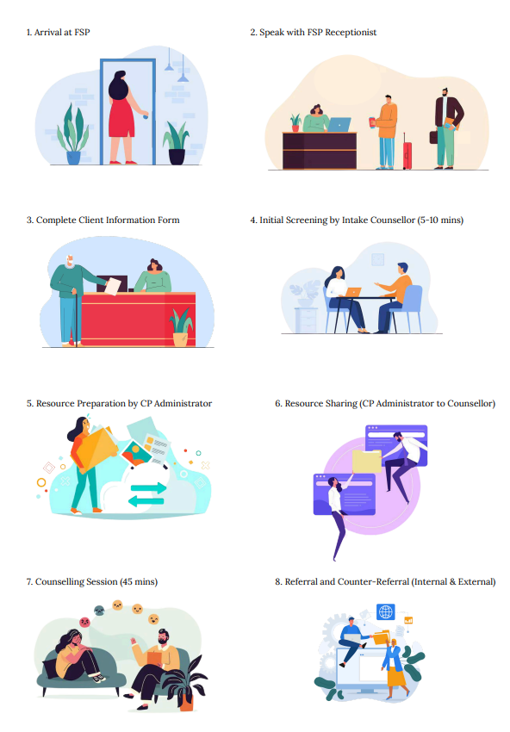

Appendix B: Scoping Review #1 Data Screening Flow Diagram

References from other sources (n = 89)
Citation searching (n = 0)
Grey literature (n = 89)
Studies from databases/registers
(n = 9428)

Identification
References removed (n = 4910)
Duplicates identified manually (n = 159)
Duplicates identified by Covidence (n = 4751)

Studies excluded (n = 153)
Studies not retrieved (n = 8)
Studies excluded (n = 4432)
Studies assessed for eligibility (n = 167)
Studies screened (n = 4607)
Studies sought for retrieval (n = 175)

Screening

Studies included in review (n = 14)
Included

Appendix C: Scoping Review #2 Data Screening Flow Diagram

Studies from databases/registers (n = 7,002)
References from other sources (n = 51)
Citation searching (n = 10)
Grey literature (n = 41)

Identification
Studies included in review (n = 48)

References removed (n = 3266)
Duplicates identified manually (n = 48)
Duplicates identified by Covidence (n = 3218)

Studies screened (n = 3787)
Studies sought for retrieval (n = 210)
Studies assessed for eligibility (n = 196)
Studies not retrieved (n = 14)
Studies excluded (n = 3577)

Studies excluded (n = 148)
Book (n = 3)
Language (n = 2)
Commentary (n = 7)
Review text (n = 14)
Wrong setting (n = 8)
Wrong outcomes (n = 6)
not accessible (n = 5)
Missing full-text (n = 8)
Outside date range (n = 9)
Wrong intervention (n = 82)
Wrong patient population (n = 3)
Screening

Included

